Random File
# Source: AI Source: Provided by: [Data Path: Persons Table -> ID Column: 1, Name_En Column: Motasem Essam] -> From: [Chatgpt (GPT‑5 Mini)] on [12/10/2025]
A random file (also called a direct access file) is a type of file in which records can be accessed directly, in any order, without reading the entire file sequentially. This is the opposite of a sequential file.

Definition:
# Source: AI Source: Provided by: [Data Path: Persons Table -> ID Column: 1, Name_En Column: Motasem Essam] -> From: [Chatgpt (GPT‑5 Mini)] on [12/10/2025]
  - A random file allows the program to jump directly to a specific record using its address or key.
  - You don’t have to read all previous records to reach a particular record.

How It Works:
# Source: AI Source: Provided by: [Data Path: Persons Table -> ID Column: 1, Name_En Column: Motasem Essam] -> From: [Chatgpt (GPT‑5 Mini)] on [12/10/2025]
  - Each record is usually of fixed size, so the system can calculate the position of any record in the file.
  - Accessing a record is fast, even in a large file.
  - Often used in databases or applications that require frequent updates.

When to Use:
# Source: AI Source: Provided by: [Data Path: Persons Table -> ID Column: 1, Name_En Column: Motasem Essam] -> From: [Chatgpt (GPT‑5 Mini)] on [12/10/2025]
  - When you need fast access to specific records.
  - For large datasets where sequential search would be slow.
  - When you want to update or delete specific records without affecting others.

Example of a Random File
# Source: AI Source: Provided by: [Data Path: Persons Table -> ID Column: 1, Name_En Column: Motasem Essam] -> From: [Chatgpt (GPT‑5 Mini)] on [12/10/2025]
Suppose we have a file students.dat with records of fixed size:
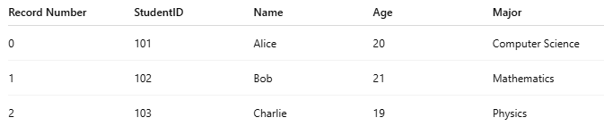
Record Number | StudentID | Name | Age | Major
0 | 101 | Alice | 20 | Computer Science
1 | 102 | Bob | 21 | Mathematics
2 | 103 | Charlie | 19 | Physics
- To read Bob’s record, the program calculates the position of record 1 and accesses it directly, without reading Alice’s record first.
- To update Charlie’s age, the program jumps directly to record 2 and changes it.

Advantages of Random Files
# Source: AI Source: Provided by: [Data Path: Persons Table -> ID Column: 1, Name_En Column: Motasem Essam] -> From: [Chatgpt (GPT‑5 Mini)] on [12/10/2025]
- Fast access to any record.
- Efficient for updates, deletions, and searches.
- Works well with large datasets.

Disadvantages
# Source: AI Source: Provided by: [Data Path: Persons Table -> ID Column: 1, Name_En Column: Motasem Essam] -> From: [Chatgpt (GPT‑5 Mini)] on [12/10/2025]
- More complex to implement than sequential files.
- Usually requires fixed-size records for easy calculation of positions.

💡 Analogy:
# Source: AI Source: Provided by: [Data Path: Persons Table -> ID Column: 1, Name_En Column: Motasem Essam] -> From: [Chatgpt (GPT‑5 Mini)] on [12/10/2025]
- Sequential file → Reading a diary page by page to find a date.
- Random file → Opening a calendar directly to the date you want.

